
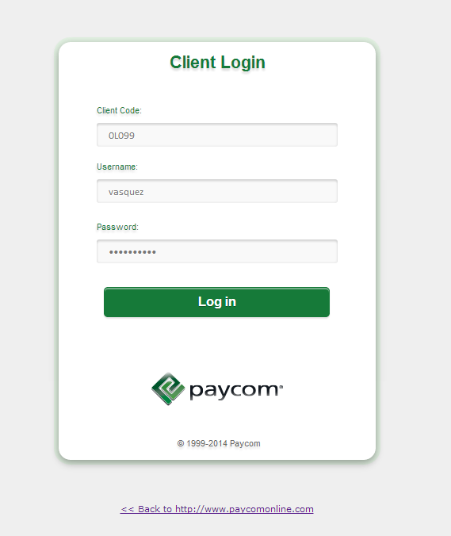
- Go to https://www.paycomonline.net/v4/cl/cl-login.php and log in using our client code 0L099 and your log in credentials. *If this is your first time logging in you will be required to enter a new password and submit security questions/answers.
SUPERVISOR TIMECARD APPROVAL PROCESS

- From the home screen, you will see a section labeled “Time Management”. Roll your mouse over the “Time and Attendance” and click.
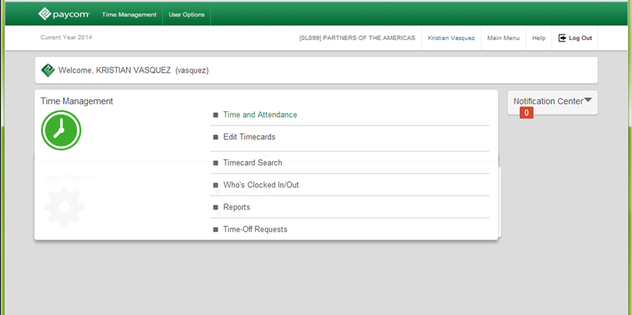

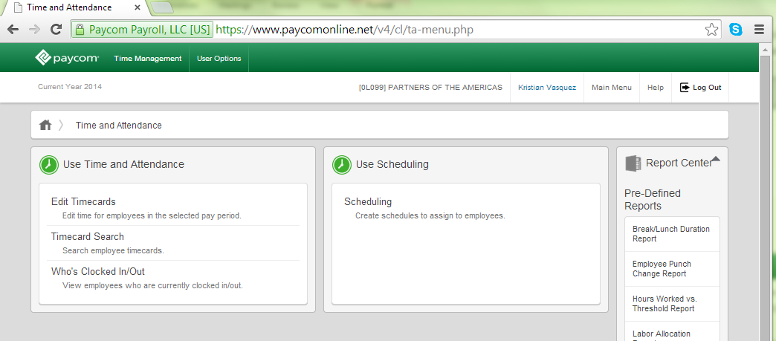
- Roll your mouse over the “Edit Timecards” section and click.

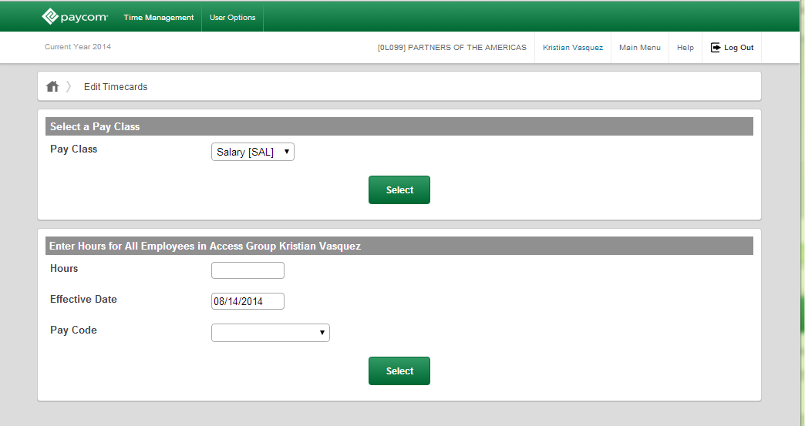
- Under the Select Pay Class Section, click on the drop down menu and select “Salary”. Then click the green “Select” button.

- In the Filters section, select the appropriate time period for which you would like to approve timecards. Then click on the green “Select” button.
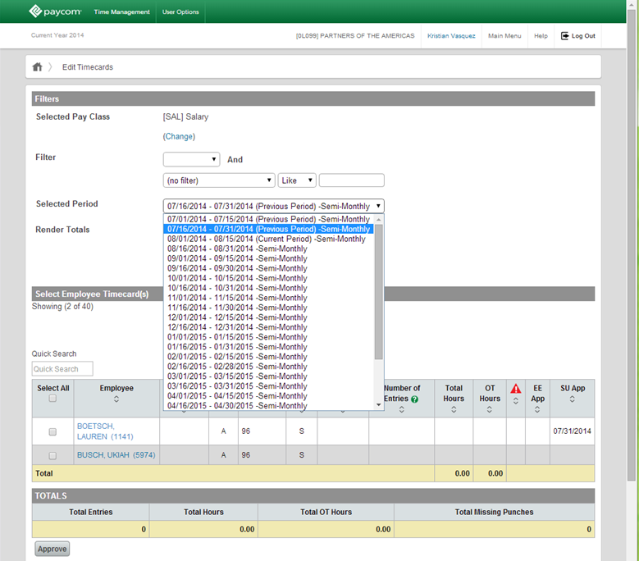

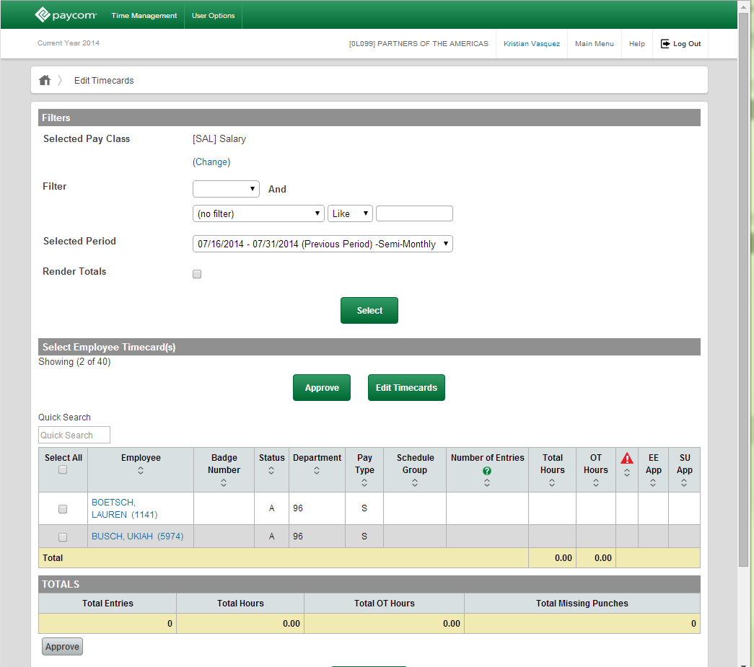
- All of your employees timecards will populate for the time period you selected. Roll over and click on the employees name ( in blue ) to view their detailed timecard.

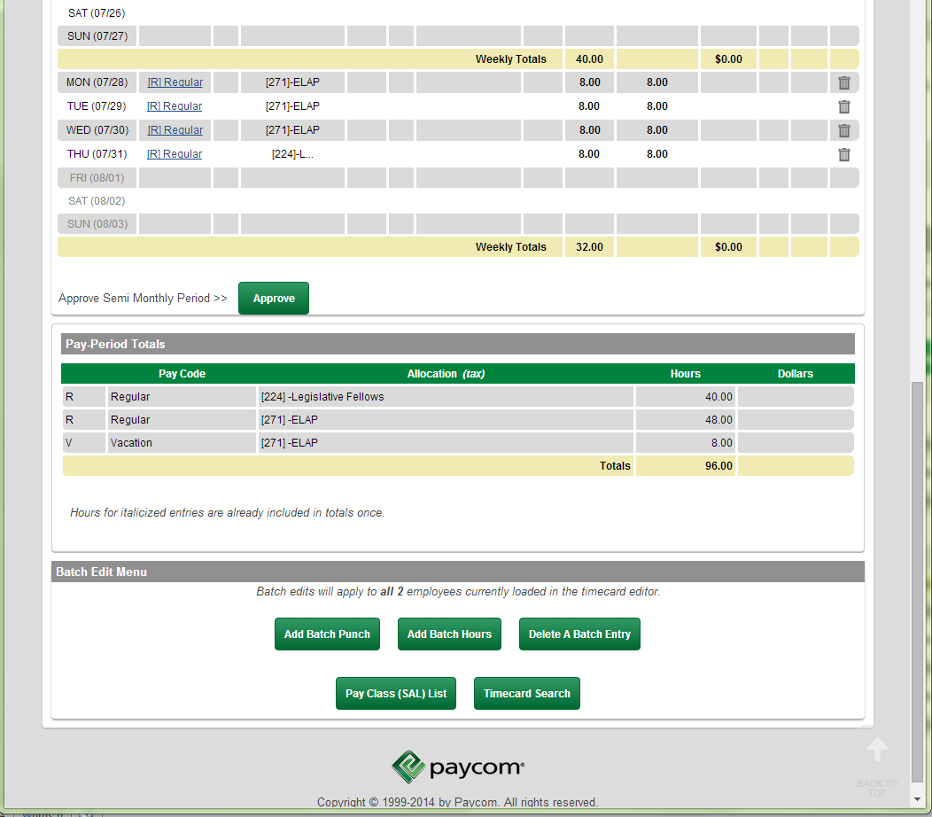
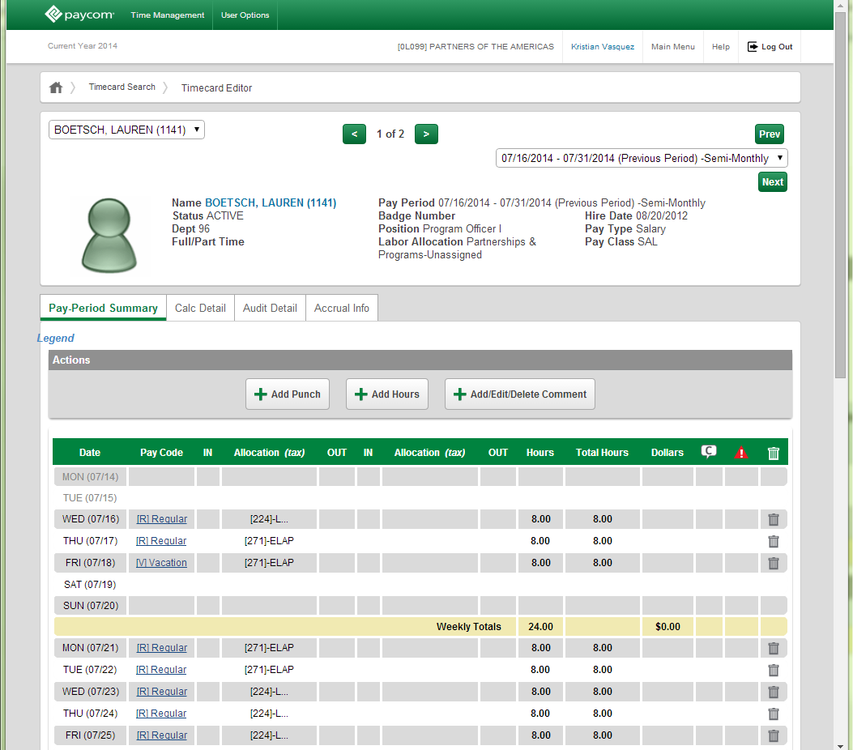
Example of a Completed Time Card

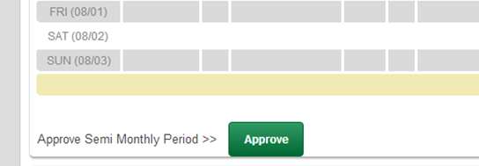
- Once you have reviewed the timecard and are ready to approve click on the green “Approve” button located at the bottom.

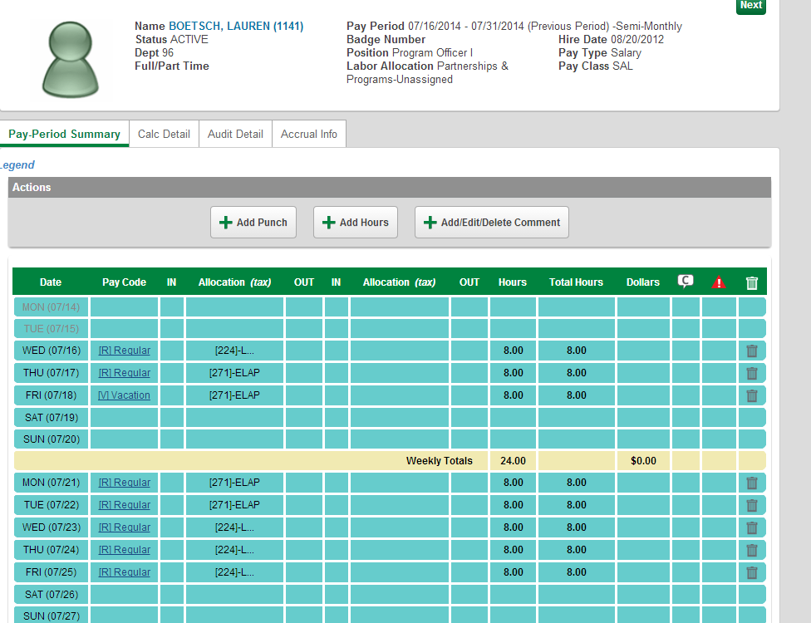
- Once it has been approved, the timecard fields will be highlighted in torquise. You will also see the “Supervisor Approved” label next to the Approve button.

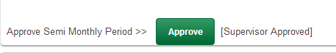

- To go back and approve the remaining timecards, scroll to the top of the page and from the drop down menu select your next employee. Repeat Steps 7 & 8.
